CONTENTS

I. INTRODUCTION 2
A. Current Set-up 2
B. Business Case 2
II. PROPOSED SOLUTION 3
A. Literature Review 3
B. Industry Benchmark 3
C. Proposed Modifications to Existing Plant 4
D. Equipment Requirements 6
E. Project Engineering Support 9
F. Plant Trial Monitoring 9
III. References 9

INTRODUCTION

This document outlines the proposal to convert the existing ammonium metavanadate (AMV) precipitation tanks into crystallizers to improve the current crystal structure of AMV and reduce the consumption of ammonium sulphate (AmSul).

Current Set-up
Clean pregnant liquor from the storage tank is pumped at a nominal rate of 10-15m3/hr to the first of three 90m³ capacity, mechanically agitated, closed AMV precipitation tanks (35TNK501, 35TNK502, 35TNK503), configured in series. The slurry flow between the tanks is driven by the head difference between interconnecting launders. A new modification into the system includes uplifters that assist in transferring the slurry from one tank to the next.

AmSul solution is pumped into the first AMV tank to precipitate out the insoluble AMV crystals. The AmSul flow controller (FIC355435) controls the speed of the AmSul liquor pump (35PPC13A) to deliver the required rate of sulphate into the precipitation stage.

The original design allowed for a cooling step of the pregnant liquor through a plate heat exchanger that was meant to cool the liquor down from 88ºC to 35ºC. However, this has been decommissioned a few years ago due to issues with the PHE blocking up regularly (anecdotal evidence).

AmSul is currently added at an excess of between 2.25-4 (moles/L AmSul : moles/L V) to reduce the vanadium in barren solution to < 1g/L.

Business Case

The current crystal structure of the AMV produced in the existing precipitation tanks have been examined by John Clout (Chief Technical Officer of MVPL). This was compared to the crystal structure of AMV produced in another vanadium processing plant in Hot Springs. The difference between the two crystal structures is significant. The MVPL produced AMV are smaller crystals with inclusions in the structure. The Hot Springs produced AMV are large, clean crystals.

PROPOSED SOLUTION

Literature Review

A desktop study conducted in 2003 for the production of AMV in Windimurra indicated that significant reductions in reagent usage can be achieved by lowering the precipitation temperature. The results for a target recovery of 99.3% are shown in Table II-1.

Table II-1 Reagent Usage as a Function of Temperature
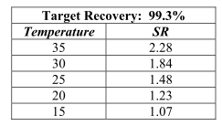
Because of the reduction in reaction temperature, it was expected that the reaction will also slow down. It was recommended that a portion of the product is recycled as seed.

Industry Benchmark

The AMV production in hot springs utilizes three crystallizers in series. The set-up is shown in Figure II-1. VPL is pumped to the first tank, where the liquor undergoes cooling before being recycled back to the tank. The tank has a center pipe/downcomer with a cap at the bottom. The heavier solids/slurry is pumped to the next tank in series and undergoes the same process as in the first tank.

The ultra fine solids are skimmed from the top of the first tank and steam heated to redissolve the solids. This liquor is then recycled back to the heat exchanger for cooling and re-crystallization.

A weir near the top of the tank transfers liquor and medium sized solids to the next tank in series.

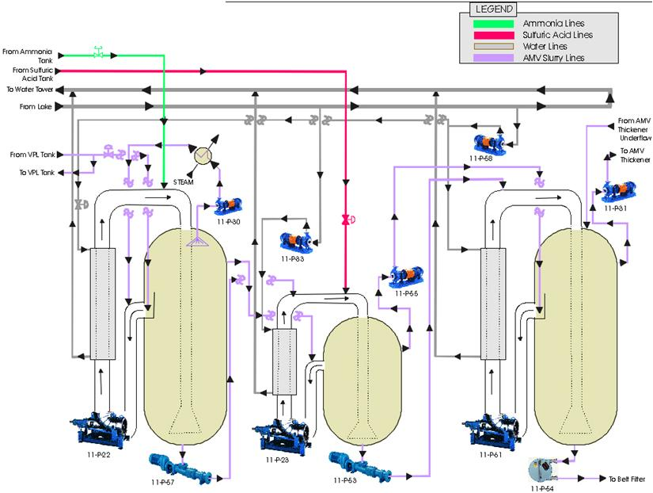
Figure II-1 Hot Springs AMV Precipitation Set-Up

Proposed Modifications to Existing Plant

The proposed modifications to the existing circuit can be seen in Figure II-2 and Figure II-3.

For the first option, the changes to be made are:
- Installation of a shell and tube or a spiral heat exchanger to cool down the clear pregnant liquor prior to precipitation from ~80ºC to ~50ºC. The flow of the cooling water will be controlled by the temperature of the cooled pregnant liquor. Flushing points will be provided on the hot inlet and outlet side to enable cleaning of the heat exchanger when there is fouling. These points can also be used as pressure gauge connections to indicate potential blockages in the heat exchanger.
- Removal of the current pipe connection between 35TNK501 (N9) and 35TNK502 (N10)
- Installation of a recycle line using the two existing flange connections (from N10 to N9) on 35TNK501. The liquor/slurry will be drawn out by a pump and passed through a shell and tube heat exchanger which will bring the temperature of the liquor/slurry down to 35ºC. There will be a temperature inidicator on the outlet side of the liquor, and the flow of the cooling water will be controlled by the slurry outlet temperature. Flushing points will be provided to enable cleaning of the slurry side.
- Installation of a downcomer (center) inside 35TNK501 for the incoming feed and AlSul dosing. The bottom of the downcomer will have a cap to allow remaining liquor and light solids to float and for the heavier solids to be drawn out from the bottom.
- Installation of a line from the drain line (N2) – the slurry will be drawn out by a pump and transferred to the 35TNK502. There will be a flow indicator and/or a flow control valve for the slurry. Flushing points can also be installed for sampling purposes (measurement of density, % solids, etc).
- 35TNK502 and 35TNK503 will have similar seed/recycle arrangement to maintain the liquor/slurry temperature to < 30ºC.
- All tanks will have pH indicators and provision to have acid addition to control pH.

Figure II-2 Proposed Set-Up, 1st Option

For the second option, the changes to be made are:
- Installation of a shell and tube or a spiral heat exchanger to cool down the clear pregnant liquor prior to precipitation from ~80ºC to ~50ºC. The flow of the cooling water will be controlled by the temperature of the cooled pregnant liquor. Flushing points will be provided on the hot inlet and outlet side to enable cleaning of the heat exchanger when there is fouling. These points can also be used as pressure gauge connections to indicate potential blockages in the heat exchanger.
- Removal of the current pipe connection between 35TNK501 (N9) and 35TNK502 (N10)
- Installation of a recycle line using the two existing flange connections (from N10 to N9) on 35TNK501. The liquor/slurry will be drawn out by a pump and passed through a shell and tube heat exchanger which will bring the temperature of the liquor/slurry down to 35ºC. There will be a temperature inidicator on the outlet side of the liquor, and the flow of the cooling water will be controlled by the slurry outlet temperature. Flushing points will be provided to enable cleaning of the slurry side.
- Installation of a downcomer (center) inside 35TNK501 for the incoming feed and AlSul dosing. The bottom of the downcomer will have a cap to allow remaining liquor and light solids to float and for the heavier solids to be drawn out from the bottom.
- The existing upcomers/air lifters will be utilized to transfer the slurry from the bottom of the tank to the tank downstream.
- 35TNK502 and 35TNK503 will have similar seed/recycle arrangement to maintain the liquor/slurry temperature to < 30ºC.
- All tanks will have pH indicators and provision to have acid addition to control pH
Figure II-3 Proposed Set-Up, 2nd Option

For both proposed options, it is recommended to install the modifications to the first precipitation tank first and optimize the process before making any changes to the two remaining tanks. Installation of flow controllers can also be added at a later point.

Equipment Requirements

- Shell and tube heat exchanger or spiral heat exchanger for the clear pregnant liquor. The estimated heat removal requirements based on three scenarios are summarized in Table II-1.
  - Minimum – low pregnant liquor flow, low ambient temperature,
  - Nominal - average pregnant liquor flow, average ambient temperature
  - Maximum – high pregnant liquor flow, average ambient temperature, lower pregnant liquor exit temperature
Table II-2 Heat Removal Requirements for Cooling Pregnant Liquor
 |  | Minimum | Nominal | Maximum
Clear Preg mass flow rate | m3/hr | 10 | 12.5 | 15
Temperature In | ºC | 80 | 80 | 80
Temperature Out | ºC | 50 | 50 | 45
Cooling Water mass flow rate | m3/hr | 11 | 26.4 | 55
Temperature In | ºC | 20 | 35 | 35
Temperature Out | ºC | 50 | 50 | 45
Heat removal requirement | kW | 370 | 460 | 645

From the original design criteria, the design flow rate for the AMV circuit for the cooling water is 50m³/hr. This is using a nominal 15m³/hr clear pregnant liquor flow, a 30ºC cooling water temperature, and clear pregnant liquor temperature drop of ~50ºC.

The proposed source of the cooling water is 50-CTR-501. Under normal operating conditions, there should be sufficient cooling water capacity for the pregnant liquor cooling requirement.

A plate heat exchanger can also be used for this duty, however it is recommended that an additional filtration step is added prior to cooling of the clear pregnant liquor, to reduce the possibility of fouling in the plates.

- A 100mm pipe will be connected to the existing connections (N9 and N10) to serve as the recycle for cooling. Based on a clear pregnant solution flow rate of 15m³/hr, and targeting a velocity of 1-2m/s (to prevent solids settling in the line), the required recycle flow rates are calculated and shown in Table II-3.

Table II-3 Recycle Flow Rates for Precipitation
Recycle length | Recycle Flow |  | Recirculating Load | Residence Time in Tank | Diameter | Velocity of Recycle Flow | Retention time of recycle in line
(m) | L/min | m3/hr | % of Tank Volume | hr | mm | m/s | s
10 | 475 | 28.5 | 33.9 | 5.6 | 100 | 1.008 | 9.92
10 | 550 | 33 | 39.3 | 5.6 | 100 | 1.168 | 8.56
10 | 650 | 39 | 46.4 | 5.6 | 100 | 1.380 | 7.25
10 | 750 | 45 | 53.6 | 5.6 | 100 | 1.592 | 6.28
10 | 900 | 54 | 64.3 | 5.6 | 100 | 1.911 | 5.23

A suitably sized pump that can provide the recycle flow rates required will be connected to pump the recycle flow to the heat exchanger for cooling prior to returning to the tank.

The cooling requirement for the recycle stream based on the minimum, average and maximum recycle flow rates shown in Table II-2 are shown in Table II-4.

Table II-4 Recycle Flow Rate Cooling Requirements
 |  |  | Minimum | Nominal | Maximum
Recycle Flow Rate |  | m3/hr | 28.5 | 39 | 15
Temperature In |  | ºC | 45 | 45 | 80
Temperature Out |  | ºC | 40 | 40 | 45
Cooling Water mass flow rate |  | m3/hr | 15 | 21 | 28.5
Temperature In |  | ºC | 30 | 30 | 30
Temperature Out |  | ºC | 40 | 40 | 40
Heat removal requirement |  | kW | 175 | 240 | 645

Project Engineering Support

The conversion of the precipitation tanks into crystallizers will require project engineering support for the following:
- Connection of the clear preg solution to a shell and tube heat exchanger
- Installation of the recycle line to a pump and heat exchanger.
- Provision of cooling water supply to the recycle line heat exchanger
- Installation of a central downcomer in the precipitation tank that will take the feed stream and the recycle stream
- Installation of a pump between precipitation tanks to transfer AMV
- Installation of necessary intrumentation and controllers for the process

Plant Trial Monitoring

A detailed plant trial proposal will be submitted once the approval for the scope of work is provided. The main items to be looked at will be particle size of the precipitate, crystal structure of the AMV and AmSul consumption vs vanadium remaining in liquor.

References

Factors Affecting AMV Precipitation Yield – Report to Precious Metals Australia Limited, Dr Greg Power – Arriba Consulting Pty Ltd, April 2006

